**Sukuna Multiple Campus**

Name: **Sunil Mainali**

Symbol no: 76214024

Subject: Digital Logics

Submitted To: Biraj Subedi

1.seven segment display cicuit:

Seven segment display is a form of electronic display device for displaying decimal numerals that is an alternative to the more complex dot matrix displays.seven segments displays are widely used in digital clocks,electronic meters,basic calculators which can able display numeric information.

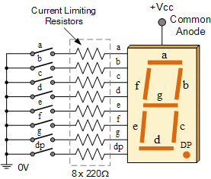

In this above figure, the segments of a common anode display are represented using the switches. If the switch is closed, current will flow through the segment of LED to the current limiting resistor connected to pin a and 0 volts which making the circuit to illuminated the segment. So a LOW condition is required to activate the LED segments on this common display.

But suppose we want the decimal number "4" to showen on the display then switches b , c, f and g should be closed to light the corresponding LED segments . similarly, in the case of decimal number "7" , switches a, b , c should be closed but the used of seven segment displays is not practical due to the circuits use the individual switches.

2. Parallel adder :

Parallel adder is binary digital circuit that produces the arithmetic sum of two numbers in parallel . It consists of full adders connected in a chain with the output carry from each full adder connected to the input carry of next full adder in the chain. In the below diagram, the are four full adders inter-connected to forming the parallel adder . In the parallel adder ,there are two inputs in which one is augend bits of A and other is addend bits of B. They are designated using subscripts from right to left where next full adder used the carry from previous adder in the chain.

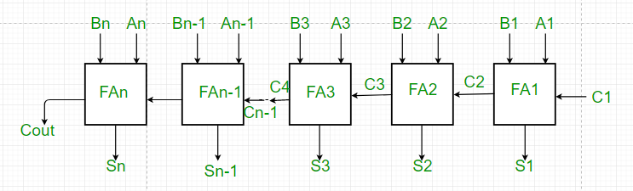

1. From the above figure, the first adder FA1 adds the input bits A1 and B1 to produce sum S1 and carry C2 which is connected to the next full adder in chain.

2. Similarly, next full adder uses the carry bit C2 from the previous adder to add with the input bits A2 and B2 to produce sum S2 and carry C3 which is further connected to the next full adder FA3 and so on.

3. This process is continued till last full adder FAn uses the carry bit Cn to add with inputs bit An and Bn to produce an output sum Sn with carry Cout.

3. Application of registers :

A registers are the group of binary cells suitable for holding binary information. Registers can be form with the group of flip-flops . moreover , n- bit register has the group of n- bit group of flip-flops which is capable of storing binary information. Register is a sequential circuit which is widely used as storage device and memory to store many information in one instance or equipment.

The main application of the register in field of information can be showen as following :

a) The main application of register is storing binary information or storing data in the digital form.

b) They also can hold data and address.

c) Registers are also used to make digital memory chips like ROM chips , Flash memory etc.

d) Cache memory in CPU is also made by registers.

The following figure can be suitable to show the advancement and application of register :

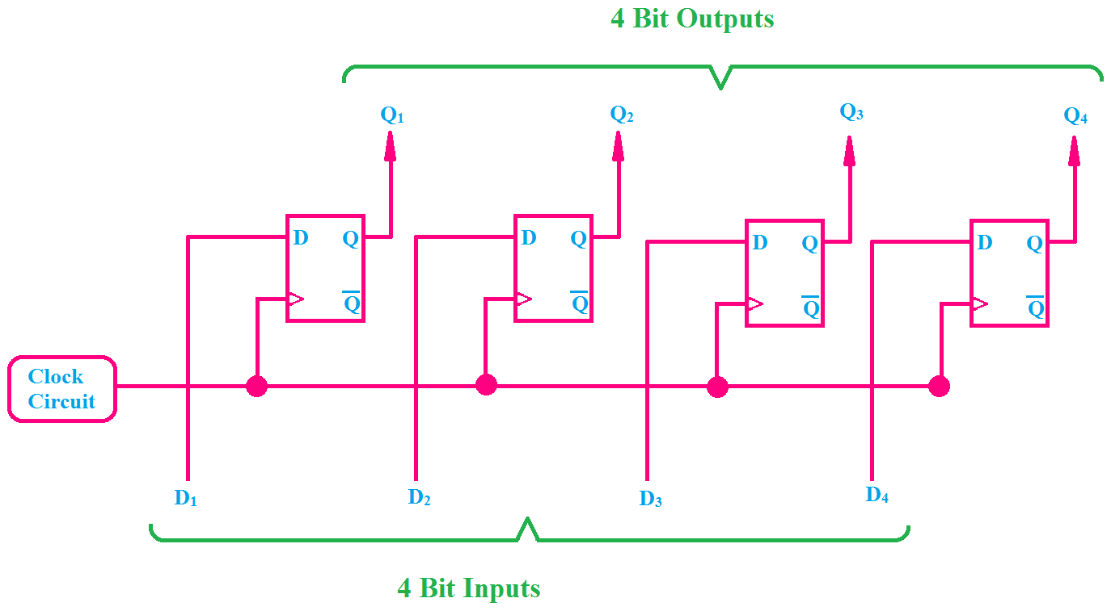

In the above figure , we can see 4-bit registers with the combination of four flip-flips where each flip- flips is capable of storing one bit binary information so the total four flip-flops can store 4 – bit data and information . we can also see that clock terminal of every flip- flops are connected together due to there is single clock pulse for the all flip-flops . In case of any storage device which formed using flip-flops , the clock pulse is always given to the all flip- flops so we are using the the D- flip-flops in this figure.

4. Brief introduction of VHDL :

VHDL stands for very high- speed integrated circuit hardware description language . It is a programming language used to model a digital system by dataflow, behavioural and structural style of modeling . This language was firstly introduced in 1981 for department of defense under VHSIC program.

VHDL is a programming language that has has been designed and optimized for describing the behavior of digital circuits and systems. VHDL has many features appropriate for the describing the behavior of electronic components ranging from simple logic gates to complete microprocessors and custom chips . It allows complex design concepts to be expressed as computer programs . This allows the behavior of complex electronic circuits to be captured into a design system for automatic circuit for system simulation.

One of the most important aspects of VHDL is its ability to capture the performance specification for a circuit ,in a form commonly refered to as a test bench.

VHDL is also called netlist and standard language. One of the most compeling reasons for you to become experienced and knowledgable in VHDL is its adoptance as a standard in the electronic design community.

In VHDL , an entity is used to describe a hardware module . an entity can be described using following tools,

* Entity declaration
* Architecture
* Configuration
* Package declaration
* Package body

The simple program of NOT gate can be describe the VHDL mechanism:

Library ieee;

Use ieee.std-logic -1164.all;

ENTITY not1 IS

PORT(X:IN STD-LOGIC; F:OUT STD-LOGIC;);

END not1;

ARCHITECTURE behv1 of not1 IS

BEGIN

PROCESS(X)

BEGIN

IF(X=="1")THEN

F<="0";

ELSE

F<="1";

ENDIF;

END PROCESS;

END behv1;

5.multiplexer and de-muliplexer:

* Multiplexer:

Multiplexer is a combinational circuit which selects the some information for multiple inputs one at a time with the help of selection line. Multiplexer generally refers to as many to one binary information using the selection line for the each input which generate only one output. Multiplexing is the process of transmiting the large number of information over single line. There are n inputs line for the m selection line which is written 2^m=1.

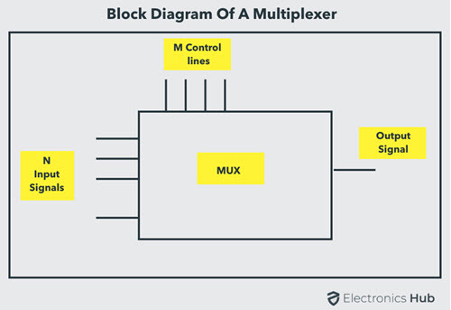

There are following types of multiplexer which used as combinational circuits:

* 2:1 multiplexer(s0)
* 4:1 multiplexer (s0,s1)
* 8:1 multiplexer(s0,s1,s2)
* 16:1 multiplexer(s0, s1, s2, s3)
* 32:1 multiplexer(s0,s2,s2,s3,s4)

2:1 multiplexer

This multiplexer used two input lines to generate one output using the selection line s0.

Inputs=D0,D1

Selection line=s0

1. Block diagram
2. Truth table
3. Cicuit diagram

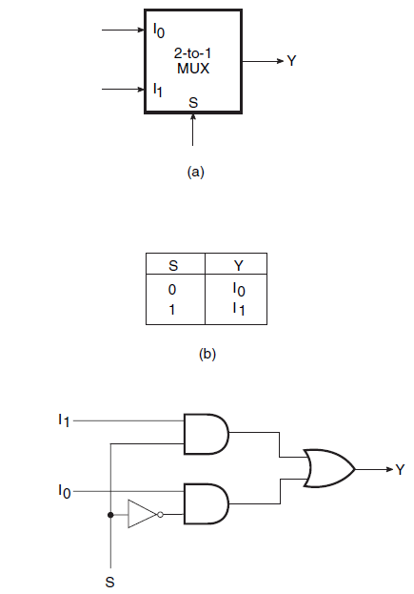

In the above circuit diagram two inputs Io and I1 to produce the function Y using s0 as selection line. There are two electronic AND gate which is combine with OR gate for the Y.

* De- multiplexer:

De-multiplexer is combinational circuits that receives information on a single line and transmits this information on one of 2^n output lines. The selection of specific output line is controlled by the bits values of n selection lines. A decoder with enable input is also called as de- multiplexer.

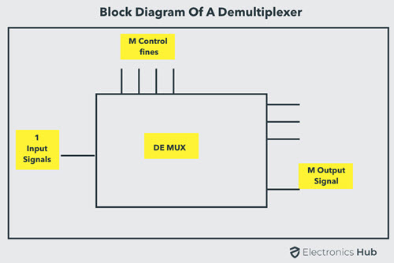

De- multiplexer is the circuits which work as the reverse of multiplexer.

2. The following table is for the 1:4 de –multiplexer so ,as we mentioned the truth table, the table will give the proper circuit diagram.

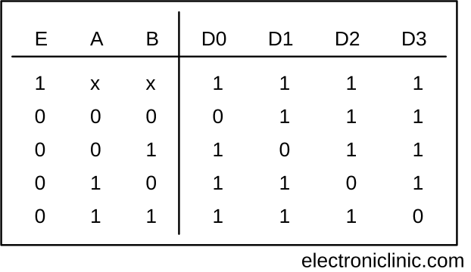

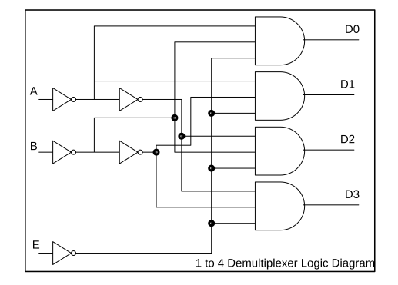

6. Introduction analog and digital devices :

Analog devices:

Analog devices process analog signals (continuous time signals ) which can take any value within a range available on its scale .the examples of analog devices are output from the speaker or microphone.

Analog system process with continuous time signal .Analog system is varying wave sine form. In the analog systems ,the variables take on continuous value with continuous time.

Analog system can display any value available on its scale but it can display many values so we are unable to read information more pricesly than about half division

Digital devices:

Digital devices process digital signals which can take only limited numbers of value (just two values are usually used : positive supply voltage and o volts).

Digital systems contain devices such as logic gates ,flip-flops , shift register and counters. In digital devices ,information variables represented by physical quantities.

Digital devices take the variables on discrete values. Moreover two level or binary values are most prevalent values in digital systems which have the bi-stable state of 0's and 1's. Digital system are less prone to error than analog system. Data representation in a digital system is suitable for error detection and correction.

7. electronic gates :

Electronic gates are digital circuits that operate on one or more input signals to produce an output signal. Electrical signals or voltages exists throughout a digital system in either one of two recognizable values (bi-state 0 or 1).

Electronic gates are also known as digital circuits , switching circuits, logic circuits and gates . Gates are the basic building block of any digital system. In the electronic gates, the relationship between the input and output is based on a certain logic. The voltage operated circuits respond to two separate voltages ranges that represents a binary variable equal to logic 1 or logic 0.

The graphic symbol used to design the three types of gates AND, OR, NOT gates and so on.

There are three types of gates in the digital electrical circuits which is shown below:

1. Basic gates: Basic gates are fundamental gates in digital circuits that can be constructed by only three gates . The basic gates are called the AND, OR ,NOT gate. These gates form the basis for other gates.
2. Universal gates: A universal gates can implement any Boolean function without used any other type gate. The NAND and NOR gates are the universal gates.
3. Exclusive gates: Exclusive gates contain the XOR (EXOR) and X-NOR gates . The XOR gate is a circuit which will give a high output if either , but not both of its two inputs are high.

An encircled plus sign () is used to show XOR gate. The X-NOR gate circuit does the opposite of XOR gate.

The following figure can systematically describe the gates system:

